**Introduction  
* In Connected Graphs**  
**Spanning Tree** => **Subgraph that contains all vertices and some (or all) edges, all vertices are connected and there are no cycles**.  
=> **All vertices, connected, no cycles**. **Minimum Spanning Tree** => **Spanning Tree whose sum of weights is minimum**.  
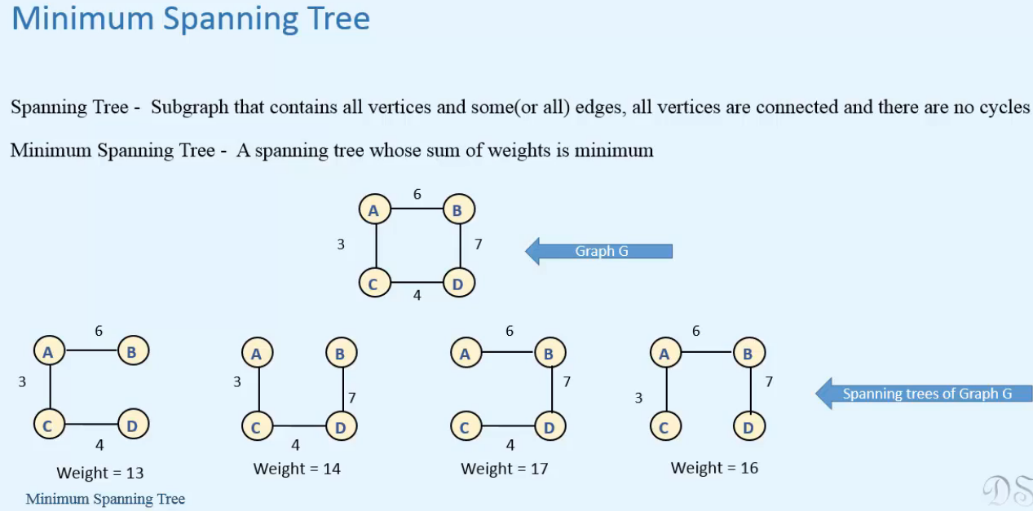  
* **More than one are possible if the graph contains some edges with equal weights**.  
* **If all the edges have unique weights, then there’ll be only 1 Minimum Spanning Tree**.  
  
=> **Both of these algorithms use Greedy Approach**.  
=> **Finding Minimum Spanning Tree gives us the most economical way of connecting all the vertices of the graph**.

**Prim’s Algorithm**  
* The procedure is similar to Dijkstra’s Algorithm.  
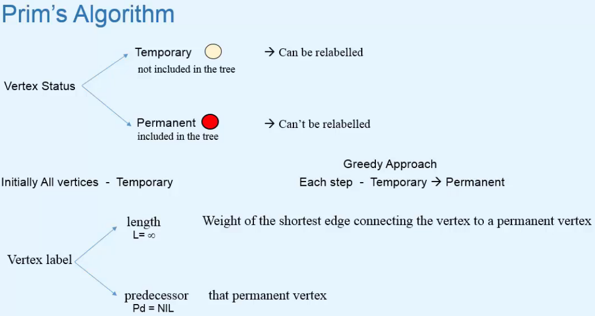  
* **The process stops when all the vertices become Permanent = are included in the Spanning Tree**.  
**length** => **weight of the shortest edge connecting the vertex to a permanent vertex**  
**predecessor** => **that permanent vertex**\* **We’ll select any vertex of the graph as root vertex**.  
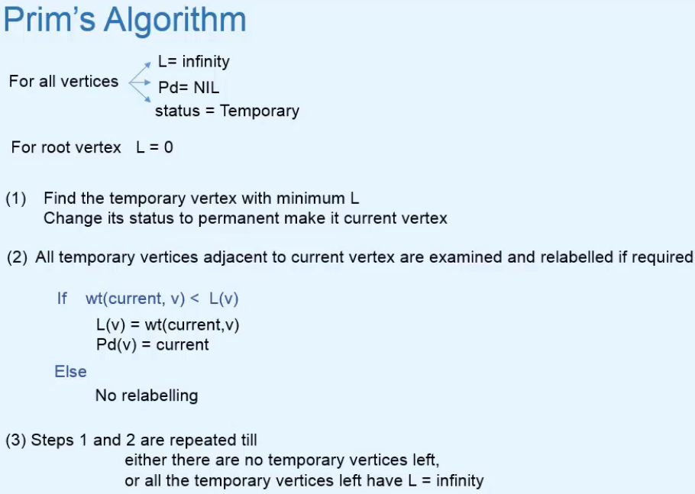  
* **If the graph is connected, all the vertices will become Permanent at the end of the algorithm**.  
* **Otherwise the unreachable vertices will remain with length oo and Temporary**.  
=> **In that case, there’s no Spanning Tree possible for the graph**.

**Prim’s Algorithm: Example**  
* **When we start and select a vertex, we make its length 0 and so it’s the Temporary vertex with minimal length and we make it Permanent**.  
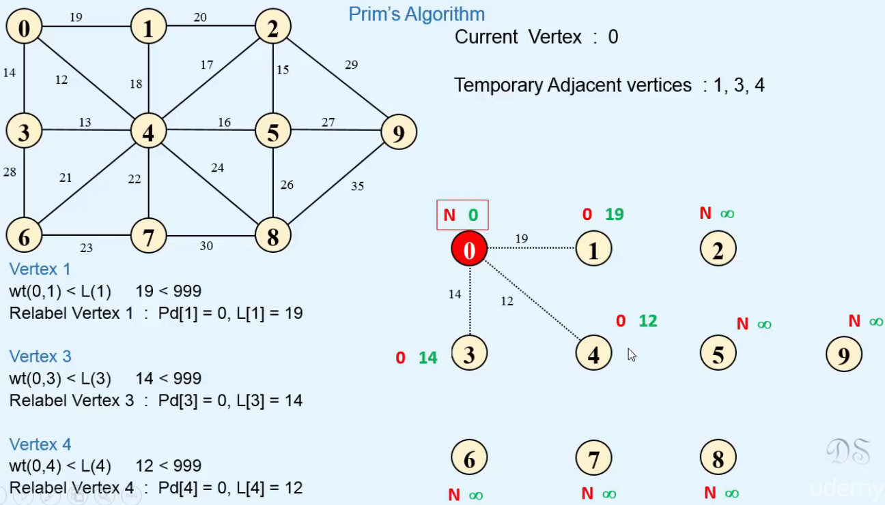

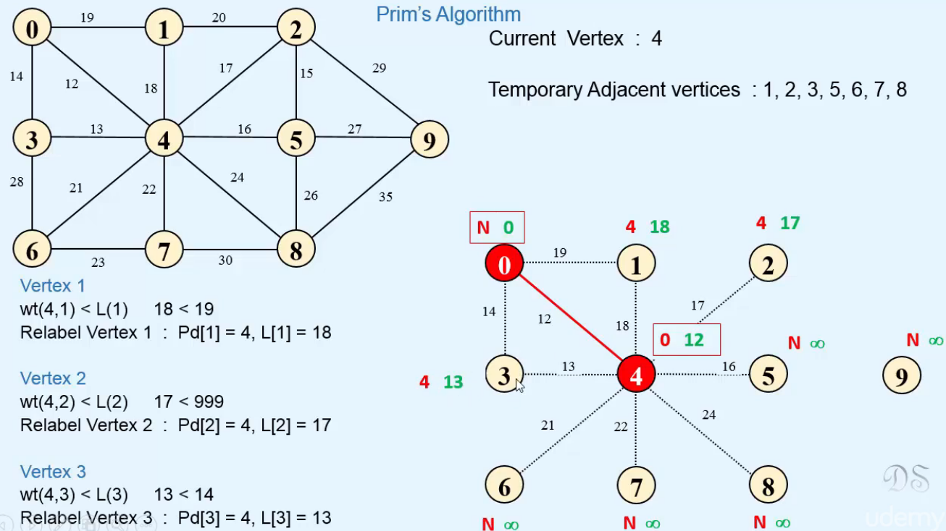

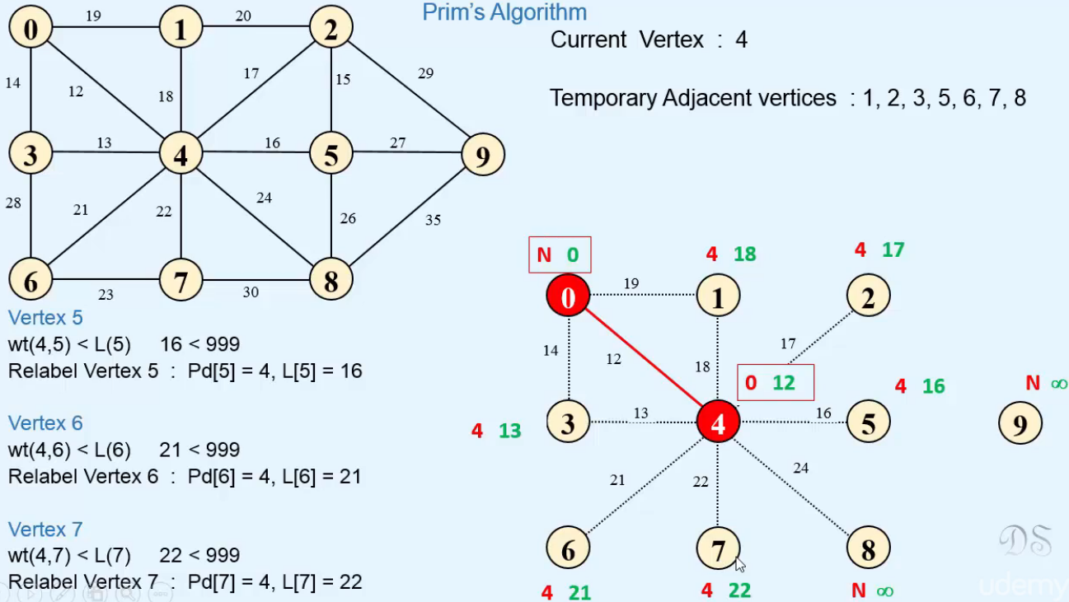

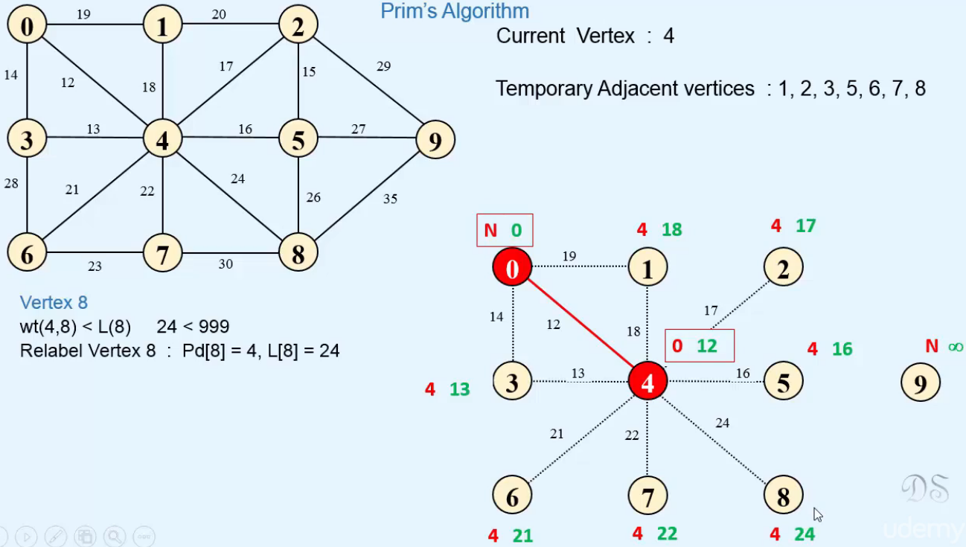

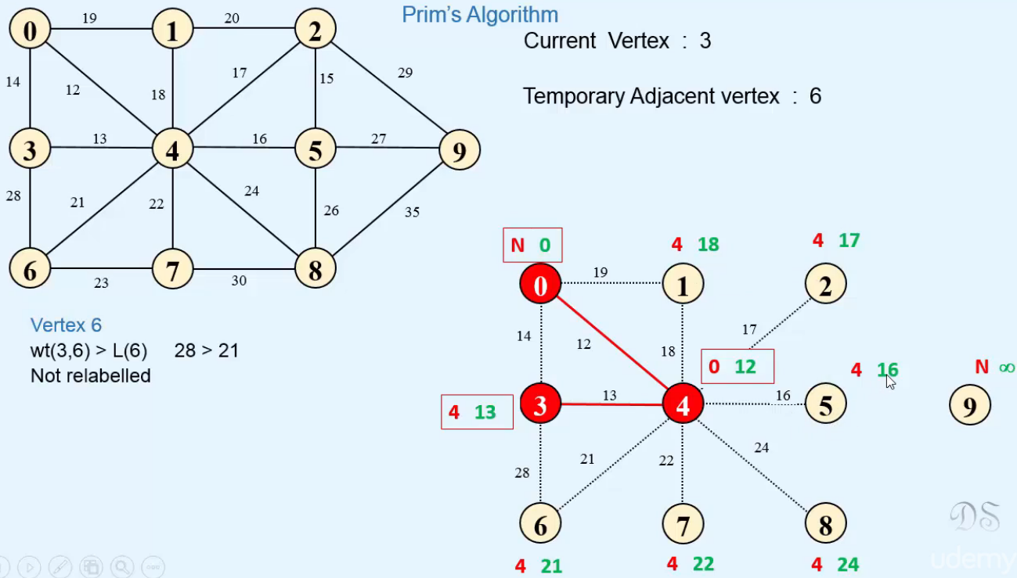

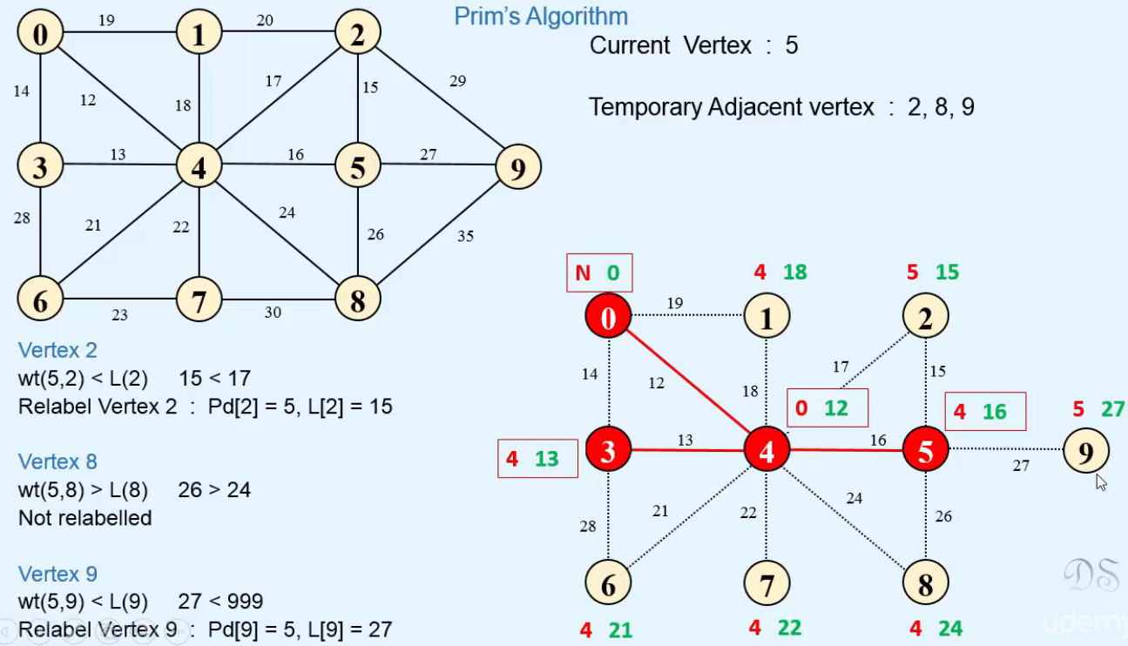

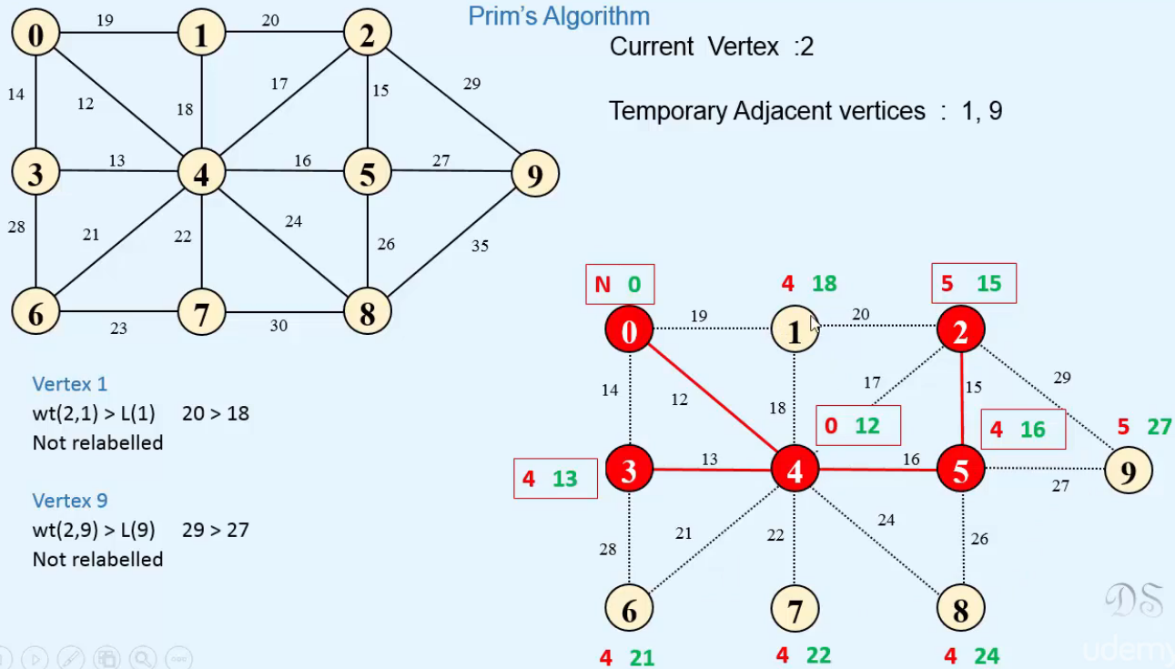

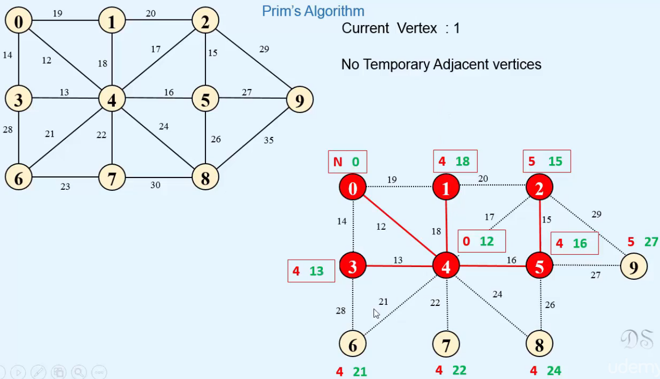

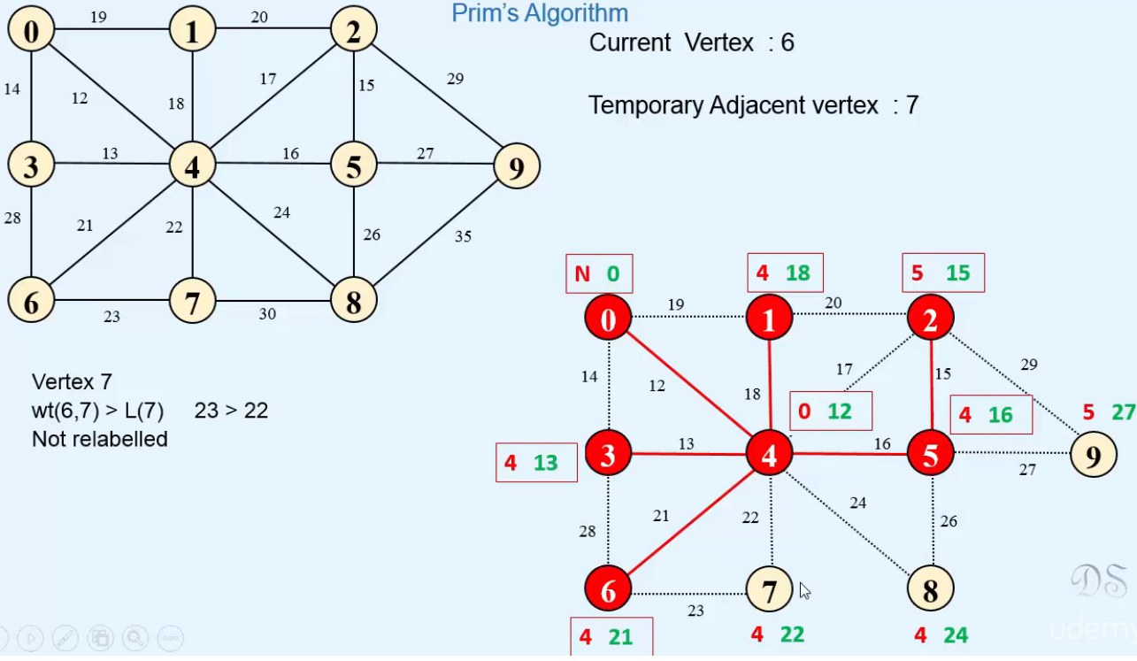

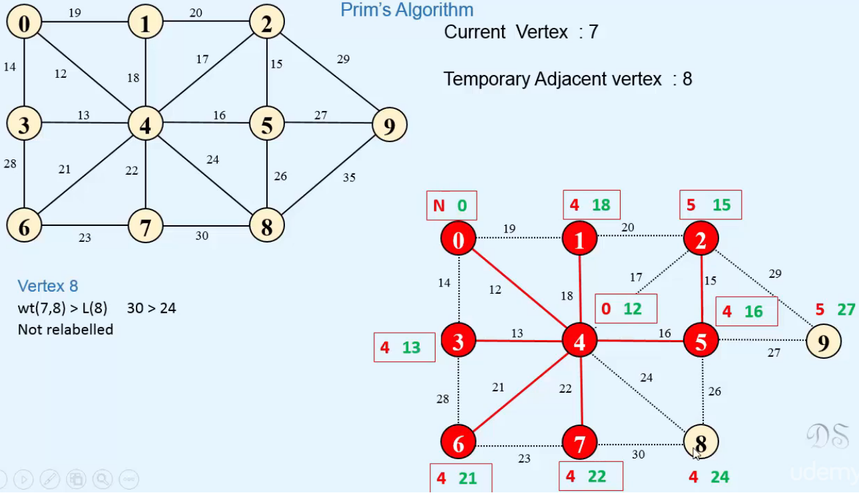

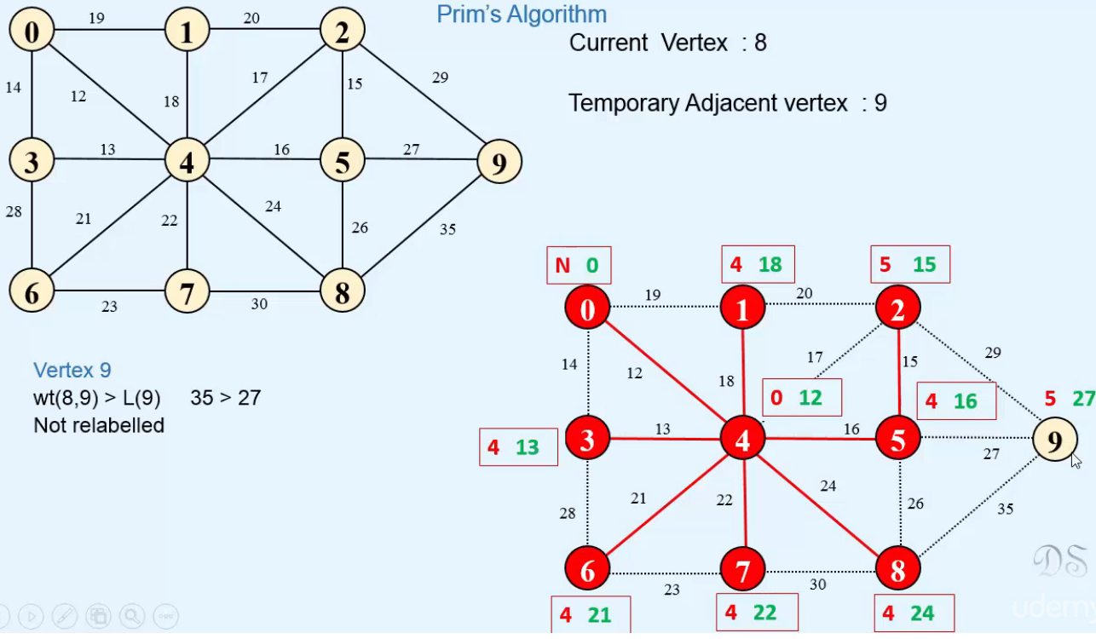

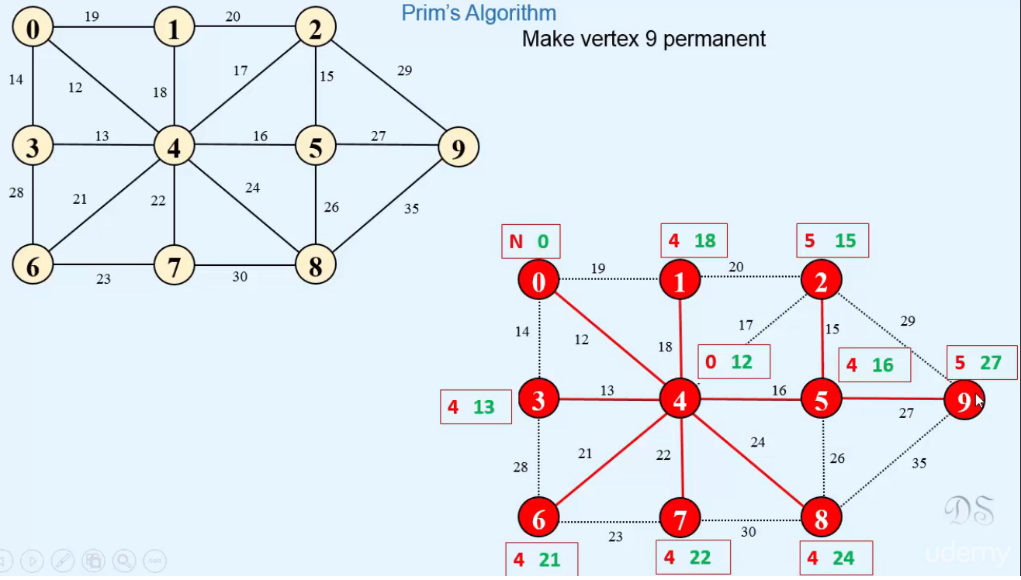  
* **Now all the vertices are Permanent and we got a Minimum Spanning Tree**.  
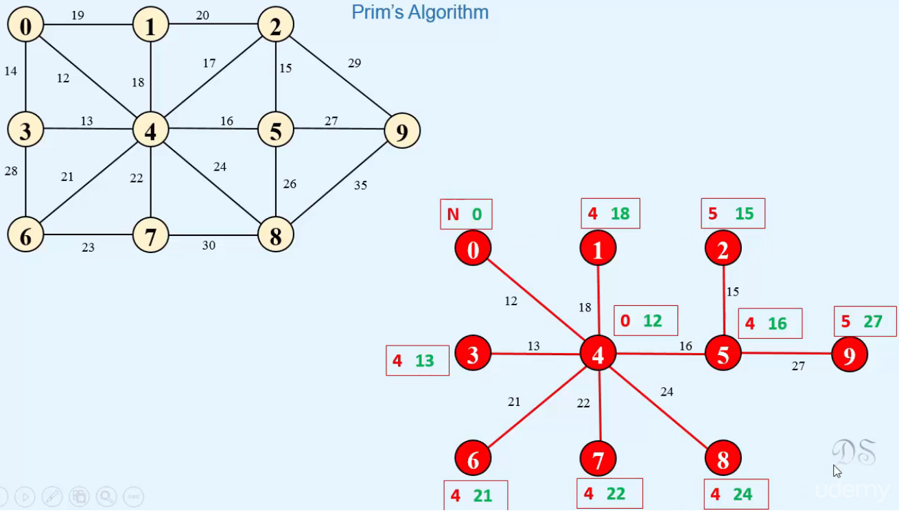

**Prim’s Algorithm in Java**  
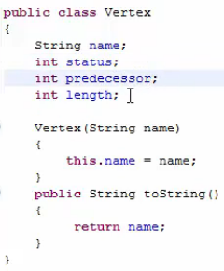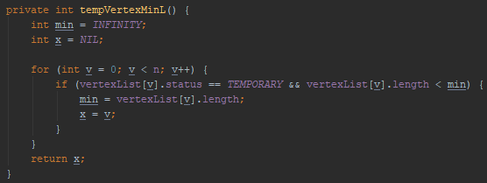  
* **The Prims() method will display the edges that will be included in the Minimum Spanning Tree and it will also display the weight of that tree**.  
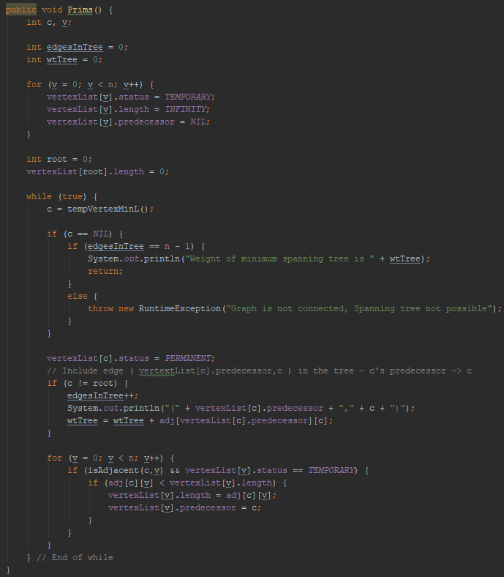

**Kruskal’s Algorithm**  
* **If we have a graph of n vertices, then at the start of the algorithm, we’ll take a forest of n distinct trees. Each tree consists of only 1 vertex of the graph and no edges**.  
=> **During this algorithm, we’ll join these trees by including some edges**.  
=> **So the number of trees will reduce in each step**.  
=> **Finally, we’ll get 1 tree which will be the Minimum Spanning Tree**.  
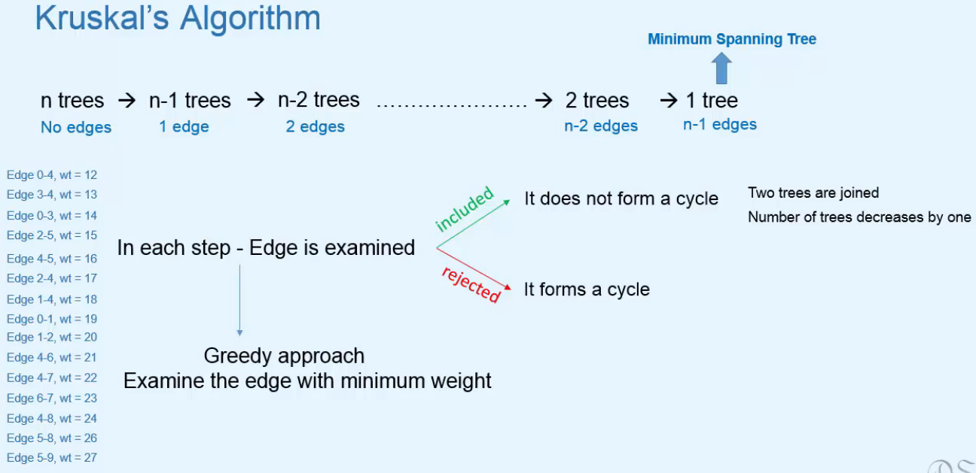  
* **We can maintain a list of edges in ascending order of their weights.**  
* **We know that a connected graph should have at least n-1 edges**.

**Kruskal’s Algorithm: Example**  
* **The list is sorted in ascending order of edge weights**.  
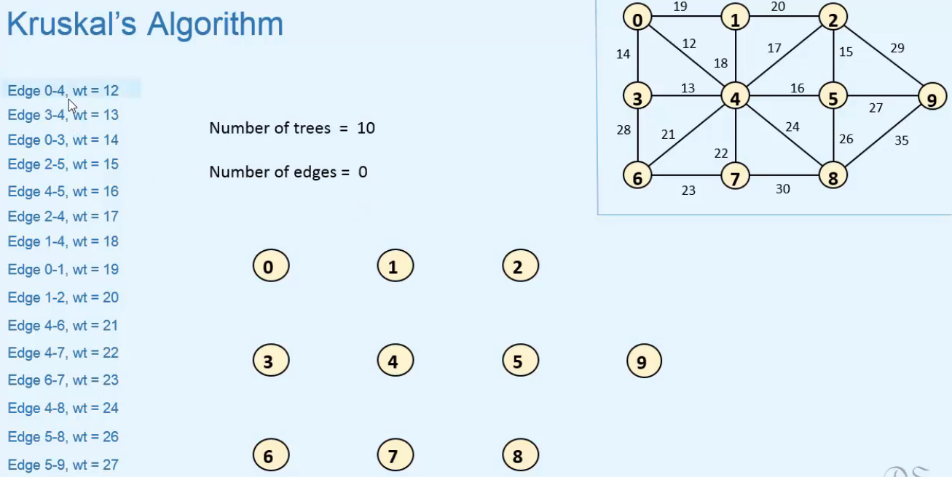

* **Edge 0-4 doesn’t form a cycle so we include it**.  
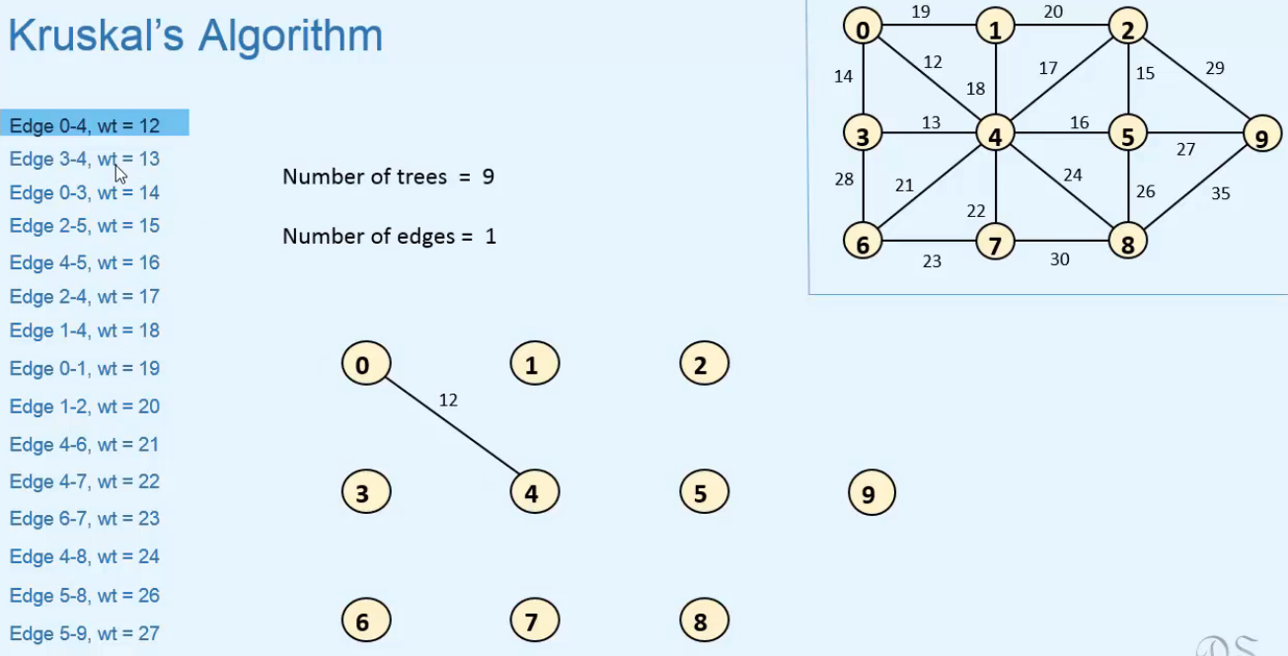  
* **Edge 3-4 doesn’t form a cycle so we include it**.  
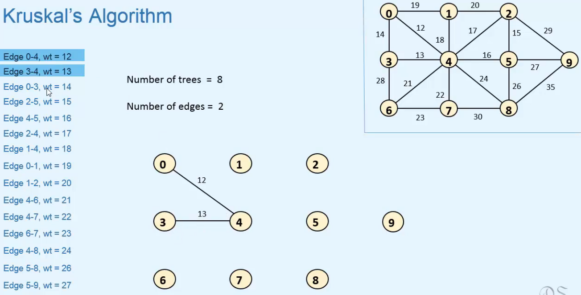

* **Edge 0-3 would form a cycle so we DON’T include it**.  
* **Edge 2-5 doesn’t form a cycle so we include it**.  
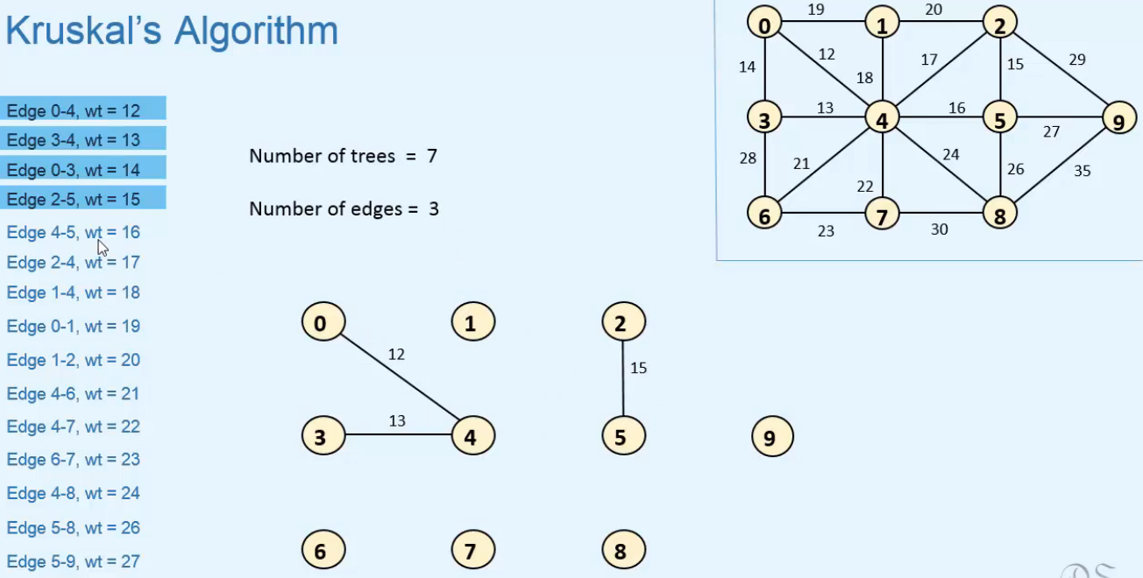  
* **Edge 4-5 doesn’t form a cycle so we include it**.  
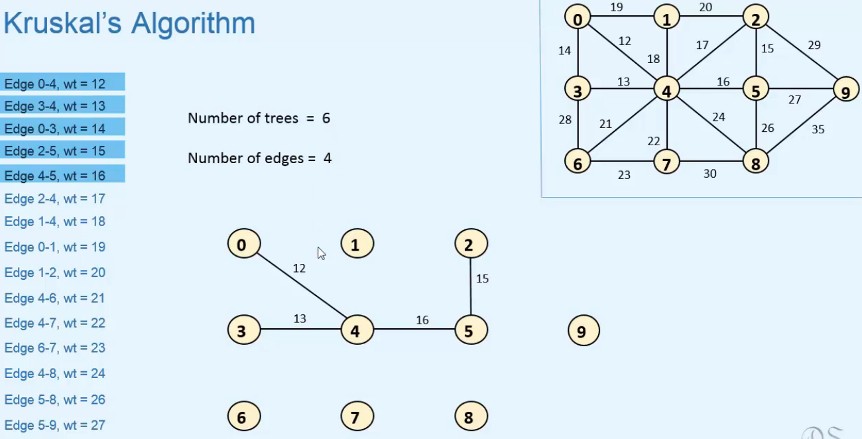

* **Edge 2-4 would form a cycle so we DON’T include it**.  
* **Edge 1-4 doesn’t form a cycle so we include it**.  
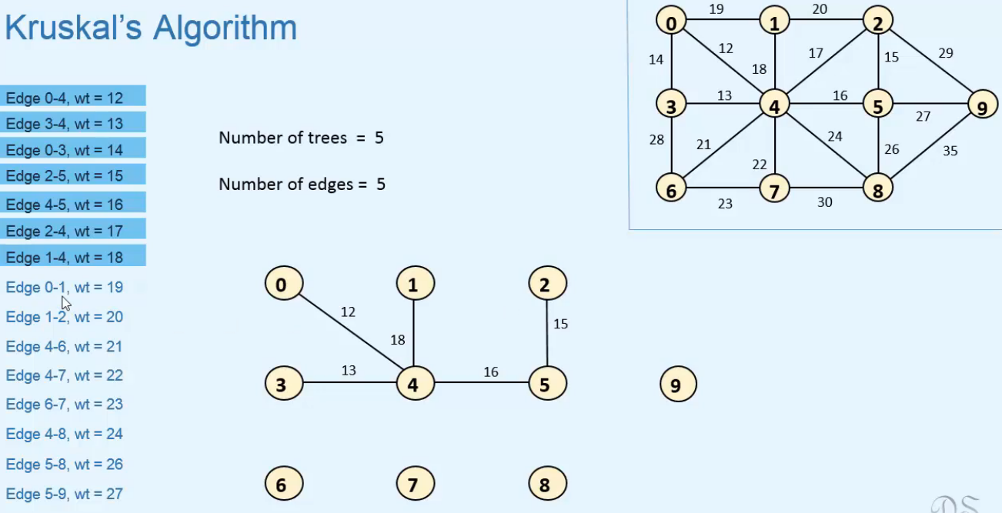  
* **Edge 0-1 would form a cycle so we DON’T include it**.  
* **Edge 1-2 would form a cycle so we DON’T include it**.  
* **Edge 4-6 doesn’t form a cycle so we include it**.  
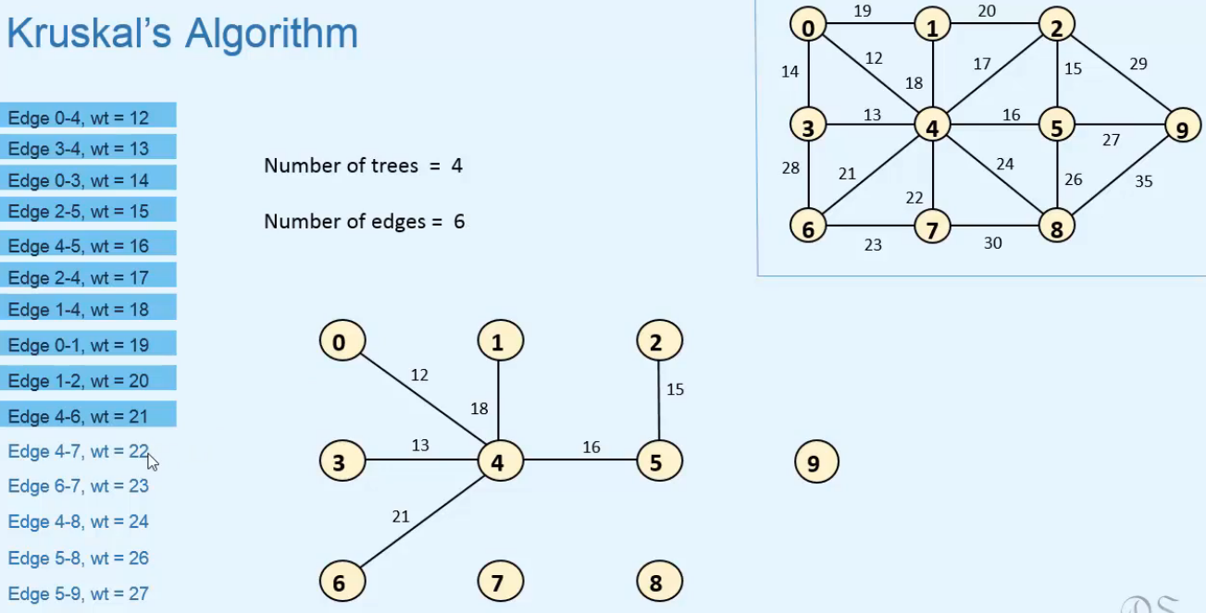

* **Edge 4-7 doesn’t form a cycle so we include it**.  
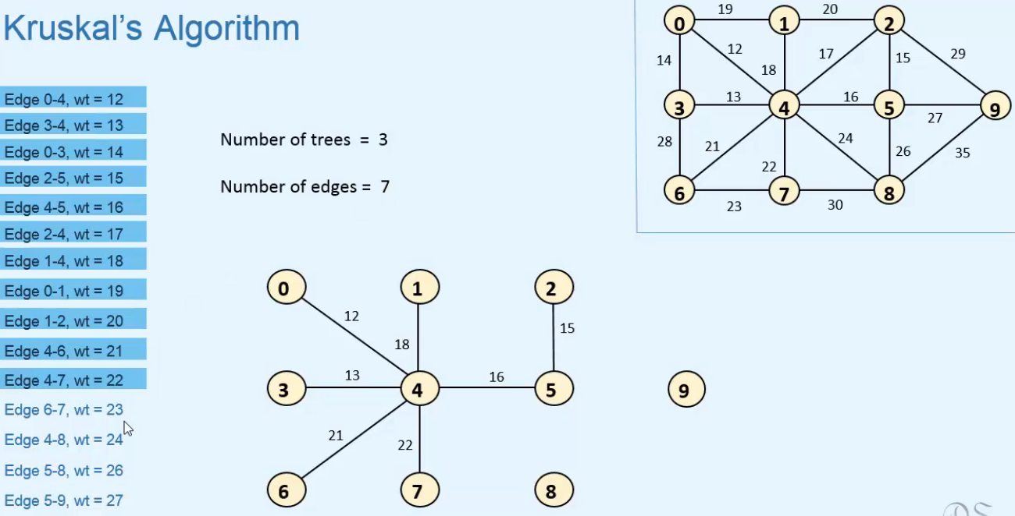  
* **Edge 6-7 would form a cycle so we DON’T include it**.  
* **Edge 4-8 doesn’t form a cycle so we include it**.  
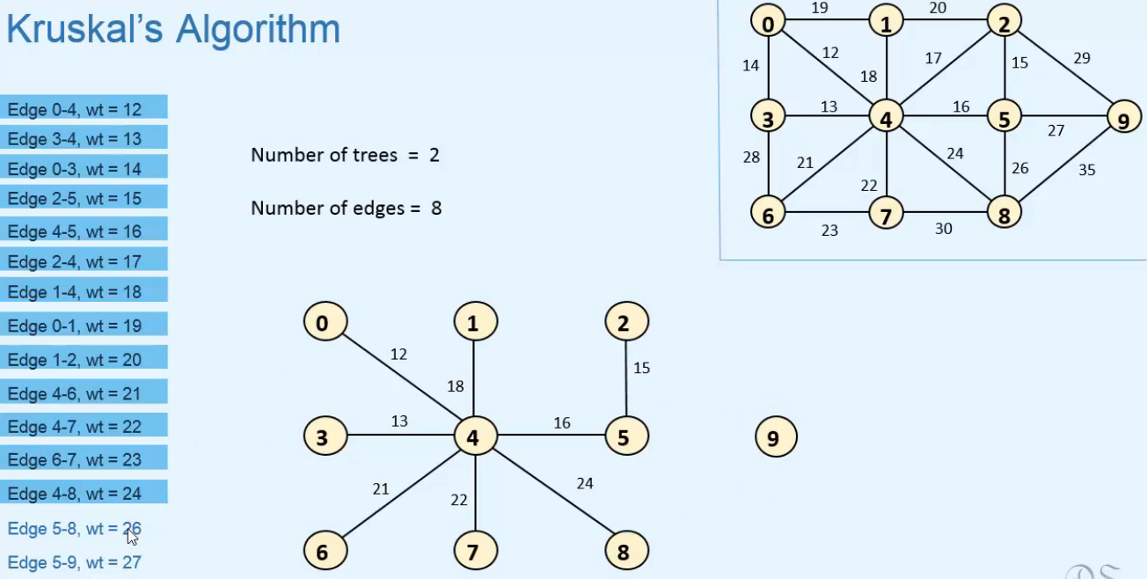

* **Edge 5-8 would form a cycle so we DON’T include it**.  
* **Edge 5-9 doesn’t form a cycle so we include it**.  
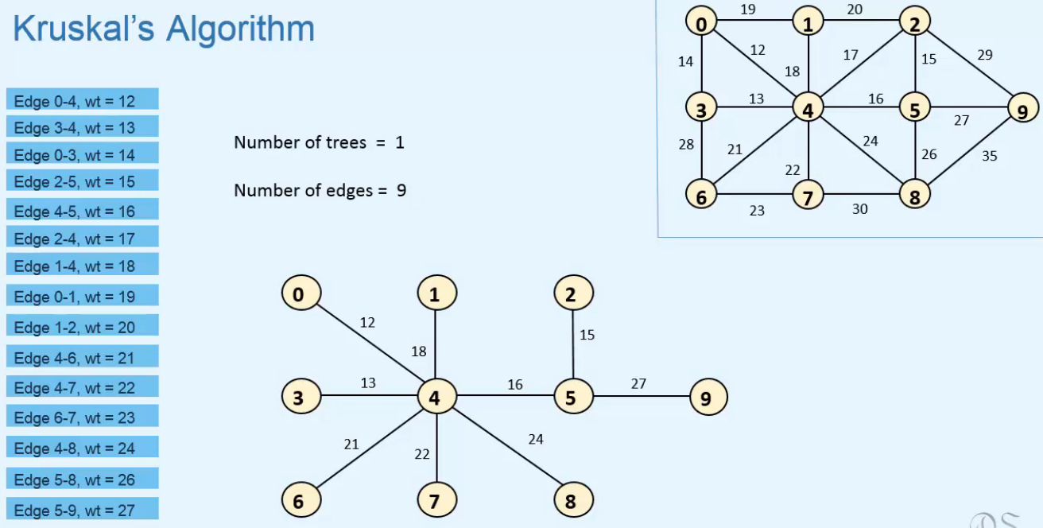  
=> **So after including n-1 edges, we have a single tree and it’s the Minimum Spanning Tree**.

**Implementation of Kruskal’s Algorithm**  
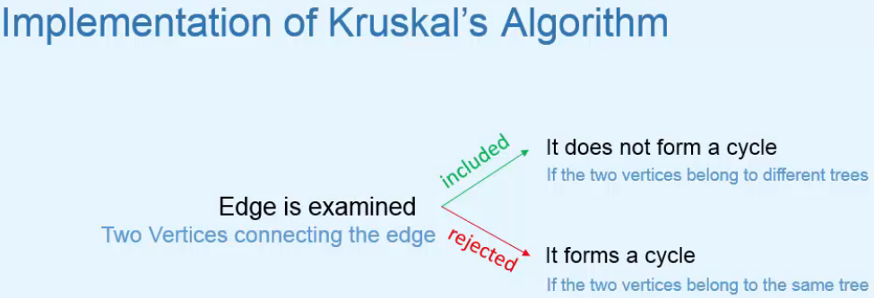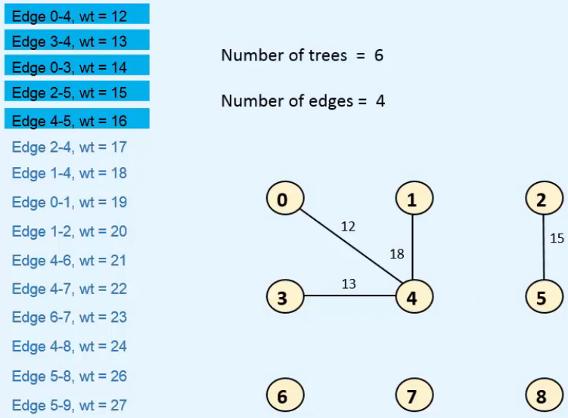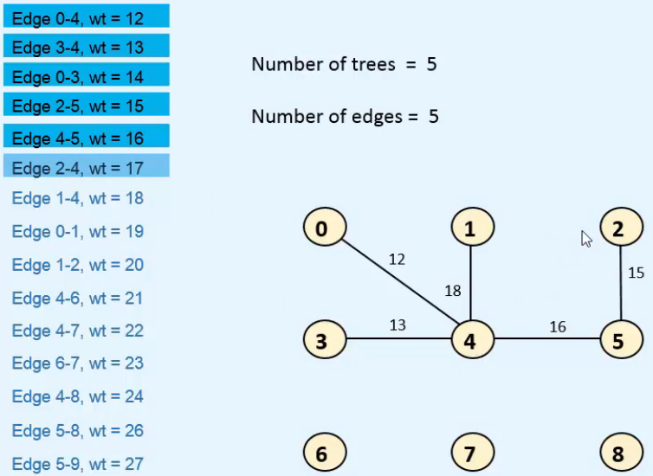  
* **If the 2 vertices belong to different trees, we include the edge connecting them**.

* **Let’s see how to decide if 2 vertices belong to different trees**.  
=> **For each vertex, we’ll keep record of a father vertex**.  
=> **Each Tree will be identified by a Root Vertex**.  
=> **Vertex will be a Root Vertex if its father = NIL**.  
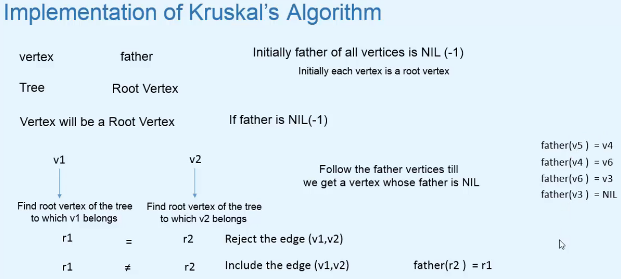  
* **Inclusion of the (v1,v2) when r1 != r2 joins the 2 trees with roots r1 and r2**.  
=> **We make root of one tree the father of root of the other tree => then both trees are connected**.  
=> **In our case the root is r1, all the vertices of both trees are now connected, r2 is no longer a root**.  
* **To find a root vertex of the tree to which v2 belongs, we follow the father vertices till we get a vertex whose father is NIL**.  
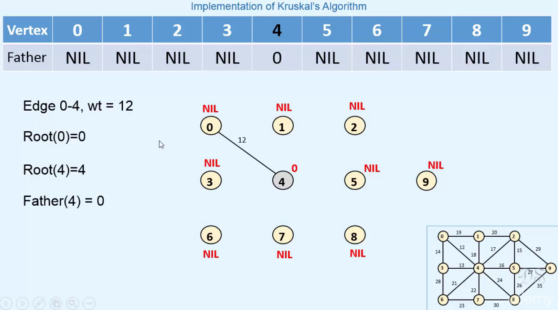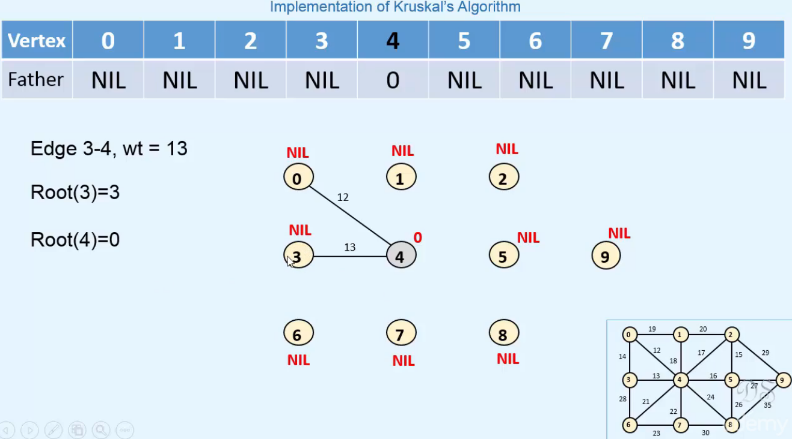

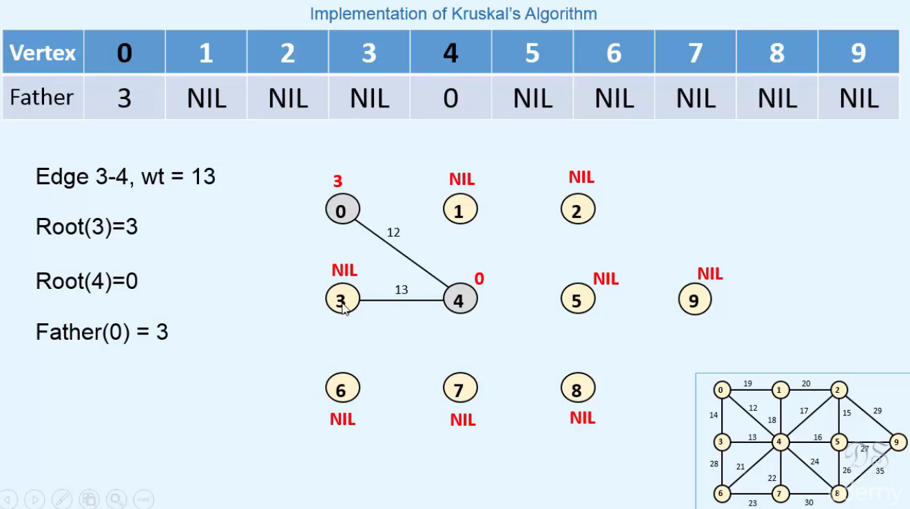  
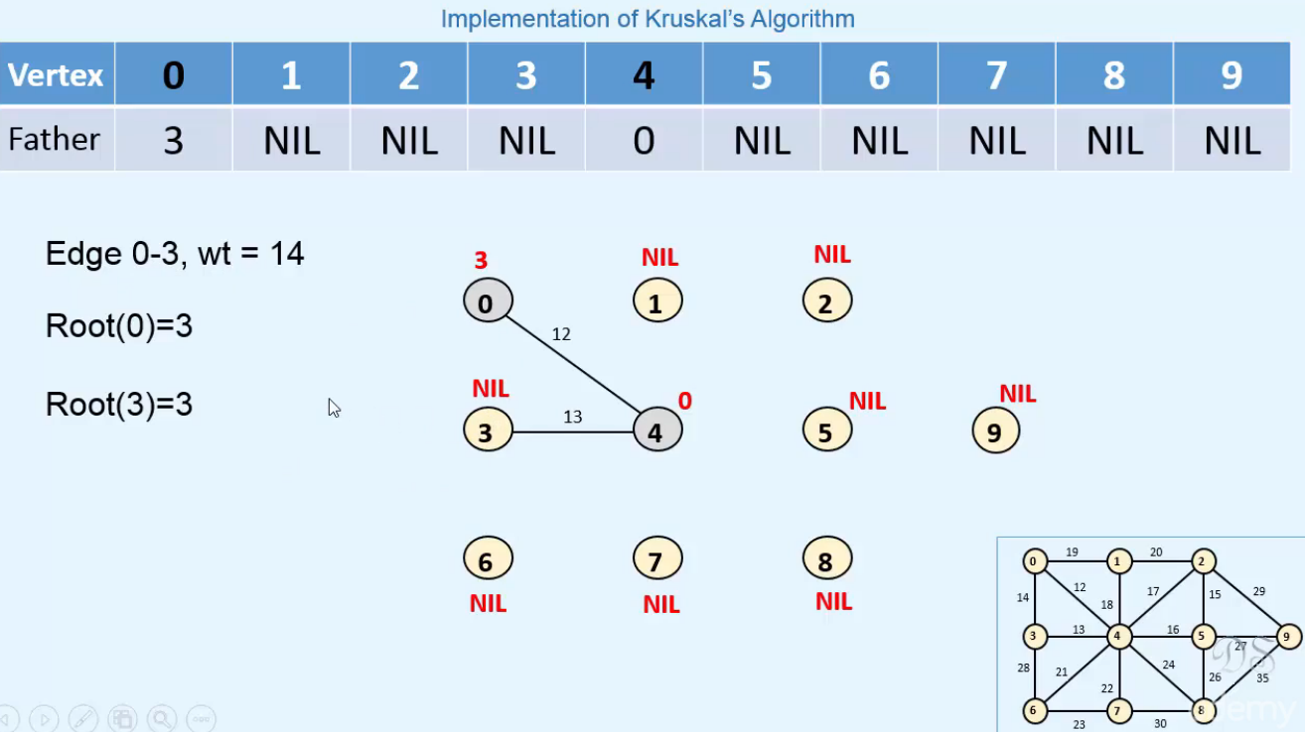  
^ both roots are 3 so we don’t include the 0-3 edge.  
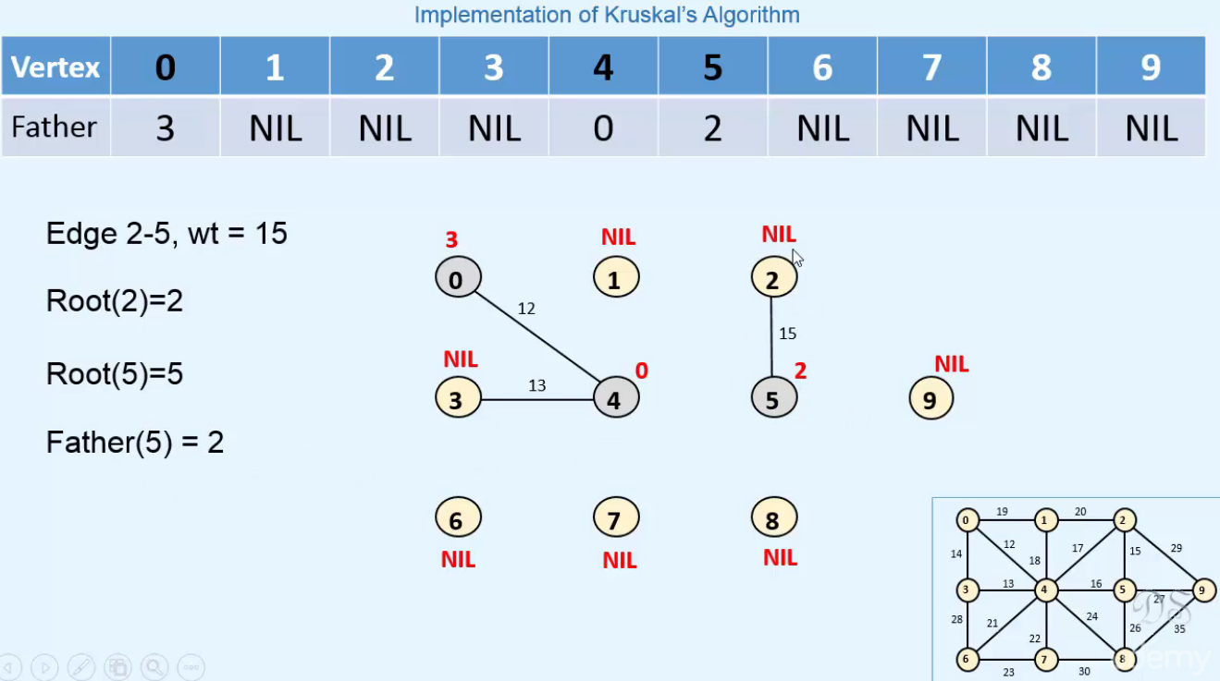

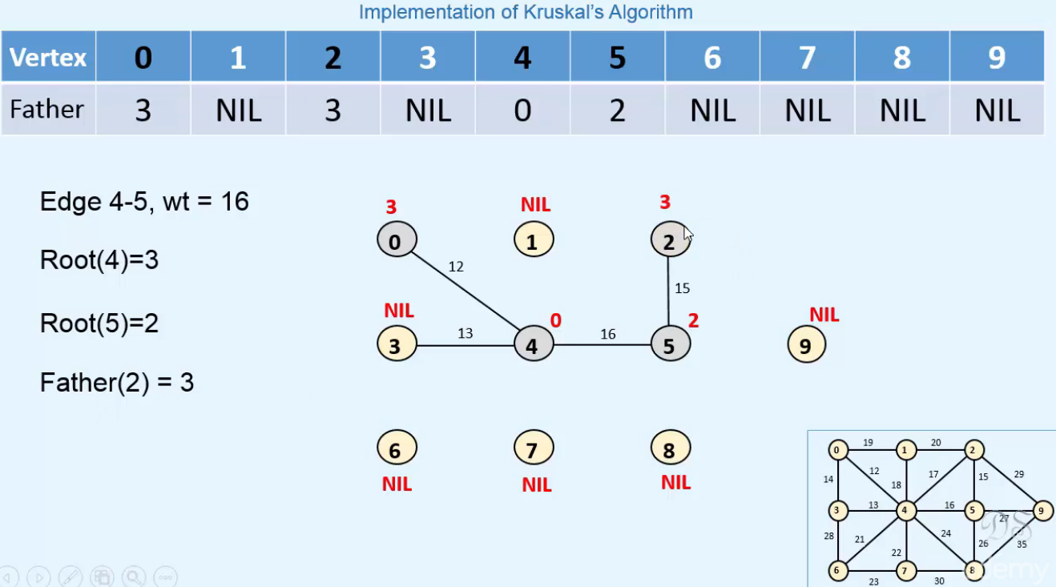  
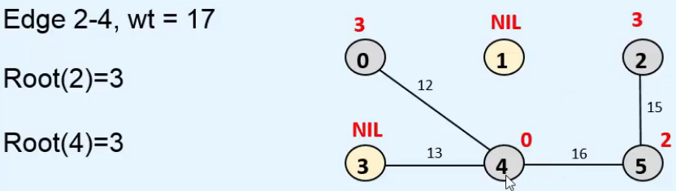  
^ roots are the same, we won’t include the edge.  
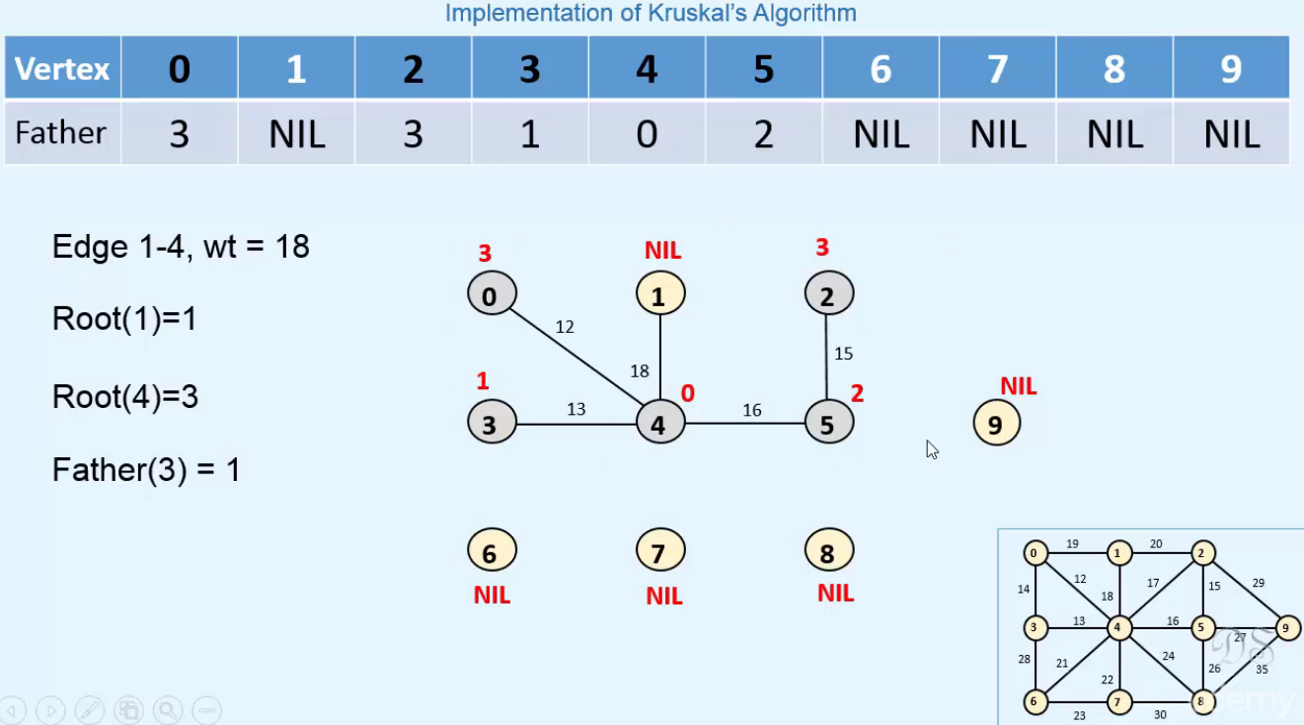  
* **We keep doing it this way**.

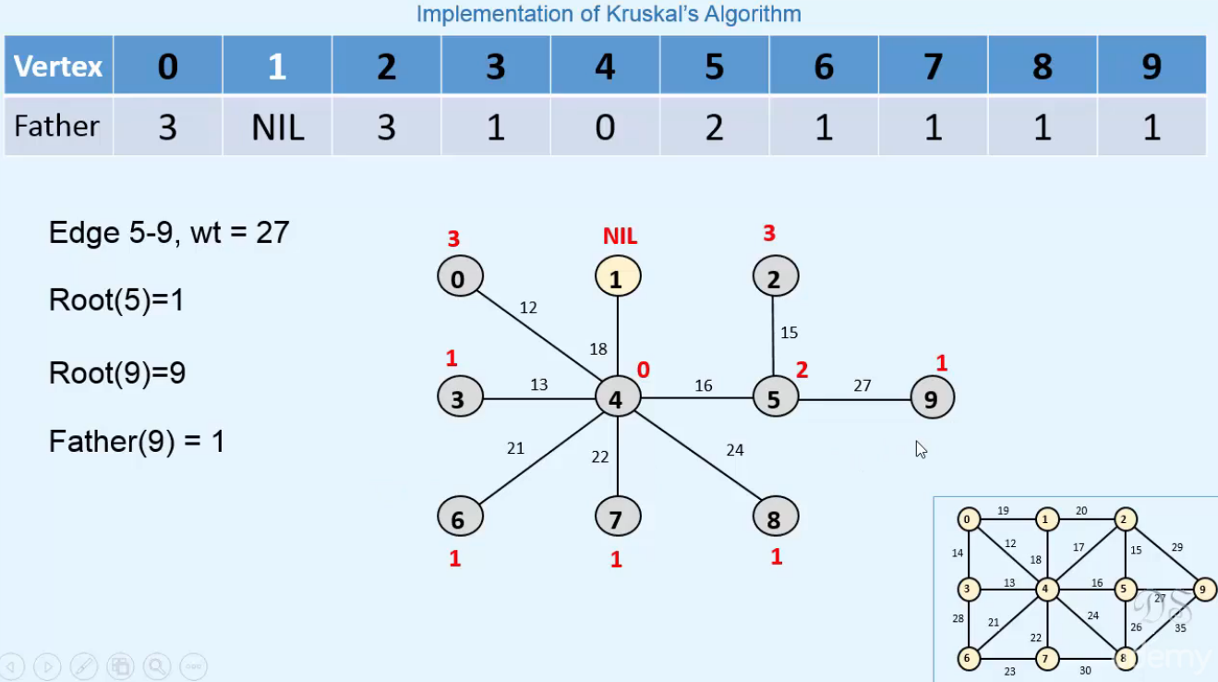  
**^ Eventually we end up with this**.  
=> **n-1 edges have been included in the tree so we have a Minimum Spanning Tree**.

**Kruskal’s Algorithm in Java**  
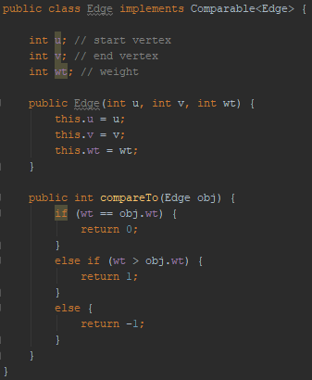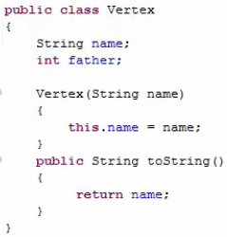  
* **We have defined the compareTo() method for Edge such that the Edge objects are ordered in terms of their weight**.  
* **While studying the algorithm, we had seen that we need to examine the Edges in ascending order of their weight**.  
* **While implementing the algorithm, we’ll take all the edges in a Priority Queue and for that we need to define the natural ordering for these Edge objects**.

* **Objects in the Priority Queue are ordered according to their natural ordering and we defined natural ordering of Edges based on their weights**.  
=> **So in this Priority Queue we have Edge objects ordered according to their weights**.  
=> **We can remove the Edges 1 by 1 and examine them, in ascending order of their weights**.  
* **We’re done when we’ve either examined all the edges of the graph or when n-1 edges have been included in the tree**.  
